For More Information
Contact
Mary Ireland, AVID Coordinator/Teacher
Oakwood Intermediate School
979/764-5530
mireland@csisd.org
https://sites.google.com/a/csisd.org/oakwood-avid-class/

Cindy Mullens, AVID Coordinator/Teacher
Cypress Grove
979/694-5600
cmullens@csisd.org
https://sites.google.com/a/csisd.org/mrs-mullen-s-5th-grade-science/

Tami Dudo
CSISD AVID District Coordinator
979-764-5608
tdudo@csisd.org
http://csisdavid.weebly.com/

AVID is an elective course that prepares students for college readiness and success, and it is scheduled during the regular school day as a year‐long course. Students must apply for entry into the elective. The process includes, but is not limited to, a written application and an oral interview. Grades, STAAR/EOC scores, attendance, and behavior records are all reviewed as part of the process. Each week, students receive instruction utilizing a rigorous college preparatory curriculum provided by AVID Center, tutor‐facilitated study groups, motivational activities, and academic success skills. Students participate in activities that incorporate strategies focused on writing, inquiry, collaboration, organization, and reading to support their academic growth. AVID has standards and has been approved as an innovative course with TEKS. The standards increase as the year of AVID increases. Students who are selected and agree to be placed in the AVID elective class also agree to enroll in rigorous courses; with rigor being determined for each individual student.

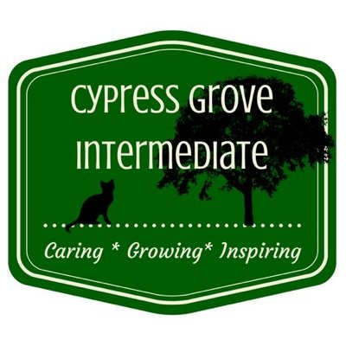
Pecan trail intermediate

ADVANCEMENT VIA INDIVIDUAL DETERMINATION
AVID's mission is to close the achievement gap by preparing all students for college readiness and success in a global society

Grades: There are no tests in AVID. Grades are made up of Tutorials, Binder Checks, Cornell Note, and additional classroom activities.

Tutorials: Students participate in tutor facilitated study groups with College students on Tuesdays and Thursday. AVID students write a question for tutorials on their Tutorial Request Form (TRF).

Expectations of AVID Students:
- Maintain a grade of 80 or higher in regular classes.
- Maintain a grade of 75 or higher in Advanced classes.
- Have good behavior, good attendance and a good attitude.
- Must be willing to work hard and study every night.

The AVID Student’s Goal is to enroll and graduate from a four-year university

AVID Activities include
- Tutorials with College tutors
- Focused notes for all classes
- Organized Student Binders
- Reading-to-Learn strategies
- Student-led Collaboration
- Field trips to College campuses
- Additional Field trips
- Guest speakers
- Community Service
- Time Management Skills
- Goal Setting
- Team-building Activities
- Philosophical Chairs
- Socratic Seminars
- Learning Logs
- Public Speaking Opportunities

- AVID students are expected to follow all of the school rules.
- AVID students are expected to be a role model to other students, and set a good example.
- AVID students represent their school, College Station ISD, and the AVID program.

